EENG 385 - Electronic Devices and Circuits

Lab 1 - Introduction to Multisim and the 555-timer

Lab Solutions

# Analysis 555 Timer

1. For what range of voltages on THR does the R-comparator output VCC?

**In order to output VCC THR needs to be larger than 2VCC/3 which equals 6V.**

1. For what range of voltages on TRI does the S-comparator output VCC?

**In order to output VCC TRI needs to be less than VCC/3 which equals 3V.**

1. SR Latch table – was given to student on purpose.
2. Now, let’s summarize our understanding of the components in Figure 2 to complete Figure 3.

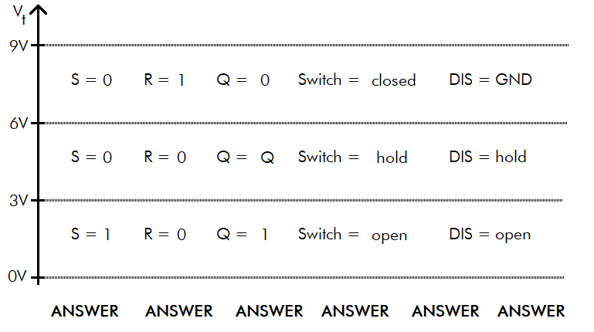

1. Determine the circuit behavior in Figure 4 when Vt between 0V-3V

* If Vt is between 0V-3V then DIS is **open** (Q=1).
* If DIS is **open** then current wants to flow from VCC through D1 to ground.
* This current flow will **charge** the capacitor with time constant RC = 47us
* The equation describing the **charging** capacitor is $V_{t}\left(t\right)=9(1-e^{-t/RC})$
* Determine the time required for the capacitor to **charge** from 3V to 6V.
  + Set the Vt(t) equation equal to 3V and solve for t. This is the time to charge from 0V to 3V. Represent your answer in microseconds and round to the nearest integer.
 $$V_{t}\left(t\right)=3= 9\left(1-e^{-\frac{t}{RC}}\right)=19us$$

 + Set the Vt(t) equation equal to 6V and solve for t. This is the time to charge from 0V to 6V. Represent your answer in microseconds and round to the nearest integer.
 $$V_{t}\left(t\right)=6= 9\left(1-e^{-\frac{t}{RC}}\right)=52us$$

 + To get the time to **charge** from 3V to 6V, subtract the time to get to 3V from the time to get to 6V. This is 52us – 19us = 33us

1. Determine the circuit behavior in Figure 4 when Vt between 6V-9V

* If Vt is between 6V-9V then DIS is **closed**, (Q=0).
* If DIS is **closed** then charge on the capacitor wants to flow through D2 to the grounded DIS.
* This current flow will **discharge** the capacitor with time constant RC = 330us
* The equation describing the **discharging** capacitor is $V_{t}\left(t\right)=9e^{-t/RC}$
* The time required for the capacitor to **discharge** from 6V to 3V
  + Set the Vt(t) equation equal to 6V and solve for t. This is the time to discharge from 9V to 6V. Represent your answer in microseconds and round to the nearest integer.
 $$V_{t}\left(t\right)=6= 9e^{-t/RC}=134us$$

 + Set the Vt(t) equation equal to 3V and solve for t. This is the time to discharge from 9V to 3V. Represent your answer in microseconds and round to the nearest integer.
$$V_{t}\left(t\right)=3= 9e^{-t/RC}=363us$$

* To get the time to **discharge** from 6V to 3V, subtract the time to get to 6V from the time to get to 3V. This is 363us – 134us = 229us

1. Assume that Vt is less than 3v.
   1. Then S = 1 and R = 0
   2. Then Q = 1 and $\overline{Q}=0$
   3. Then DIS is **open**
   4. Then the capacitor is **charging**
   5. Then it takes 33us to **charge** the capacitor from 3V to 6V.
2. Assume that Vt is greater than 6V.
   1. Then S = 0 and R = 1
   2. Then Q = 0 and $\overline{Q}=1$
   3. Then DIS is **closed**
   4. Then the capacitor is **discharging**
   5. Then it takes 229us to **discharge** the capacitor from 6V to 3V.
3. Assume that Vt is between 3V and 6V.
   1. Then S = 0 and R = 0
   2. Then Q and $\overline{Q}$ are unchanged
   3. Then DIS remains unchanged
   4. Then the capacitor charging state remains unchanged
   5. Until Vt goes below 3V or above 6V
4. I want you to plot Vt vs. time.

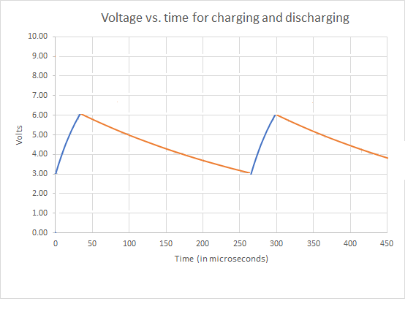

1. Use this information to determine the time high, time low, and period of the waveform.

**The time high is 33us, time low 239us and period of 239us + 33us = 272us**

1. Use the period to determine the frequency of the waveform.

**1/272us = 3.68kHz**

1. The duty cycle of a waveform is the percentage of time that it is at a high voltage level. What is the duty cycle of the OUT pin.

**It is 100*(33us/272us) = 12%.**

**Simulation 555 Timer**

# Save your file by clicking on the 3x3 grid of squares in the upper left corner and select “Save”.

1. Export an image of your schematic using the export option in the main menu to output a png file of the schematic.

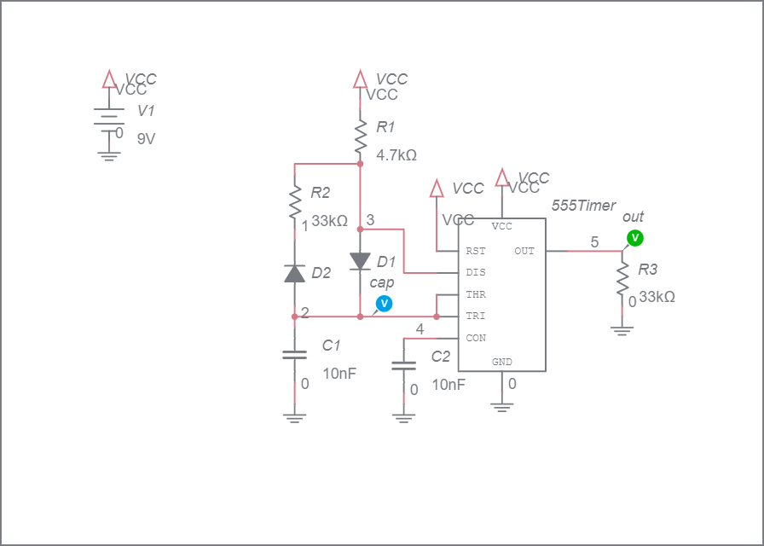

1. Simulate your schematic for 1ms. Export an image of your timing diagram using the export option in the main menu to output a png file of the schematic. You will notice that the duration of the time low will be significantly different from your analysis. This is because the assumptions you made about the diode in the analysis are not very accurate.

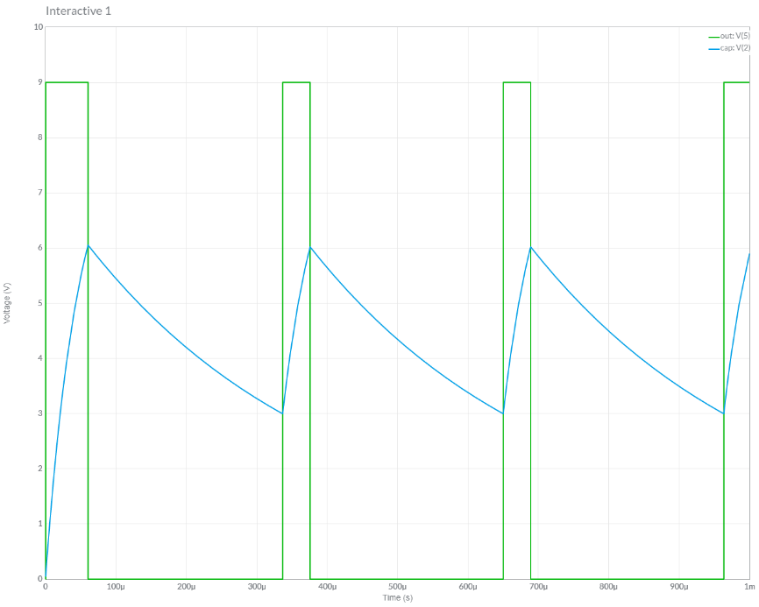

1. Use the timing diagram to measure the Time high, time low, period, frequency and duty cycle of the waveform on the OUT pin. You may find the Cursor function in the Item tab to come in handy. You should find these values very close to those in the analysis.

**Time high =39 us**

**Time low = 275us**

**Period = 314us**

**Frequency = 3.18kHz**

**Duty cycle = 12.4%**

1. Use the timing diagram to measure the high and low voltages of the TRI pin. You may find the Cursor function in the Item tab to come in handy.

**High = 6.0V Low = 3.0V**

**Assembly 555 Timer**

Table 1: Complete the missing entries in the table of resistance color codes.

|  |  |  |  |  |
| --- | --- | --- | --- | --- |
| Value | Band 1 | Band 2 | Band 3 | Band 4 |
| 220 | Red | Red | Brown | Gold |
| 2.2k | Red | Red | Red | Gold |
| 3.3k | Orange | Orange | Red | Gold |
| 4.7k | Yellow | Purple | Red | Gold |
| 6.8k | Blue | Grey | Red | Gold |
| 10k | Brown | Black | Orange | Gold |
| 15k | Brown | Green | Orange | Gold |
| 33k | Orange | Orange | Orange | Gold |
| 47k | Yellow | Purple | Orange | Gold |
| 100k | Brown | Black | Yellow | Gold |
| 470k | Yellow | Purple | Yellow | Gold |

**Part Identification**

# To make sure that you can positively identify all the elements in the schematic complete Table 3 by filling in the Match column with the letter that corresponds to the Schematic Symbol in for that Physical Part.

Table 3: Match the schematic symbol with the corresponding part.

|  |  |  |  |
| --- | --- | --- | --- |
| Schematic Symbol |  | Match | Physical Part |
| A |  | D | WCAP-ATG8 |
| B |  | F | 151051VS04000 |
| C |  | E | Goldmax 32 Series |
| D |  | A | PJ-202A |
| E |  | I | TC254P |
| F |  | B |  |
| G |  | J |  |
| H |  | G | DO-35 |
| I |  | H | CF 4-7k |
| J |  | C | EG1218 |

# Turn in:

Make a record of your response to numbered items below and turn them in a single copy as your team’s solution on Canvas using the instructions posted there. Include the names of both team members at the top of your solutions. Use complete English sentences to introduce what each of the following listed items (below) is and how it was derived.

**Analysis:** Question 1, 2 Voltage to assert S and R

**Analysis:** Question 3 SR Latch truth table

**Analysis:** Question 4 Vt vs. TRI state

**Analysis:** Question 5 Time to charge 3V to 6V

**Analysis:** Question 6 Time to discharge 6V to 3V

**Analysis:** Question 7 Behavior when Vt is less than 3V

**Analysis:** Question 8 Behavior when Vt is greater than 6V

**Analysis:** Question 10 Plot Vt vs. time

**Simulation** Question 1 Schematic output from simulation

Question 2 Grapher output from simulation

Question 3 OUT waveform characteristics

Question 4 TRI waveform characteristics

**Assembly**  Table 1 Resistance color code

Table 3 Parts Identification

Screen capture of 555 timer output

**Analysis**

Complete the columns of the following table using the information you found throughout this lab. Represent your answer to 3 significant figures using the units given in the quantity column. You will be completing this table in lab 2, so make sure to save your answers.

|  |  |  |  |
| --- | --- | --- | --- |
| Quantity | Analysis | Simulation | Assembly |
| Time high (us) | 33.0us | 39.0us | 38us |
| Time low (us) | 239us | 275us | 260us |
| Period (us) | 272us | 314us | 295us |
| Frequency (kHz) | 3.68kHz | 3.18kHz | 3.37kHz |
| Duty Cycle | 12.0% | 12.4% | 12.8% |